Title: Synergy Masterclass on " Procurement, tendering and decision-making processes in the hospital setting"
Dates: 4-5 October 2019
Link to website: http://www.eahp.eu/synergy-masterclass/events/procurement

Synergy Masterclass Venue:
Hotel Van der Valk Brussels Airport
Culliganlaan 4b
1831 Diegem (Brussels), Belgium
Brussels

Hotel accommodation:
Hotel Van der Valk Brussels Airport
Culliganlaan 4b
1831 Diegem (Brussels), Belgium
Brussels

Registration fees:
The registration fees are set as follow (VAT excluded, 21% will be added at the end):
- Non-Members € 400 (VAT excluded)
- EAHP Members € 200 (VAT excluded)

The registration fee includes the attendance to the 2-day Synergy Masterclass and the Synergy Masterclass package including all the printed materials.

Registration link: https://events.eahp.eu/cmgateway/SyMa2019.html

Description:
EAHP is glad to announce the expansion of the Synergy programme to provide continuing education and further advance the hospital pharmacy profession throughout the world.

In the second EAHP Synergy masterclass the themes of Procurement, tendering and decision-making processes will be explored. Particularly, nowadays the challenge of costly medication in hospital pharmacies is a topic that should be addressed. Thus, procurement and tendering are topics related to managing medication costs, which are essential for hospital pharmacists to understand in order to address the increasing medication costs.
Hence, the aim of this Synergy Masterclass is to demonstrate the procurement and tendering discipline to hospital pharmacists.

Learning objectives
- to recall important EU-legislation with regard to procurement;
- to recognise pros and cons by doing procurement and tenders at national, regional and hospital level, respectively;
- to list elements of value-based procurement.

Organiser: European Association of Hospital Pharmacists (EAHP)

Website organiser: http://www.eahp.eu

Short description organiser:
The European Association of Hospital Pharmacists (EAHP) is a not-for-profit organisation that defends the interests of more than 21.000 European hospital pharmacists from its 35-member associations. EAHP works to develop knowledge on hospital pharmacy to ease the improvement of care and outcomes for patients in the hospital setting. We achieve this through science, practice, research, education, as well as sharing best-practice and responsibility with other healthcare professionals.
Pictures:

EAHP LOGO
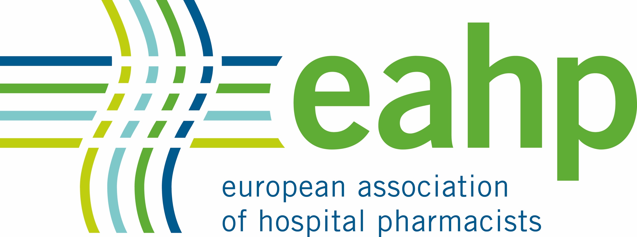
Banner for Synergy masterclass

